Lab 08 - Manage Virtual Machines

#### Task 1: Deploy zone-resilient Azure virtual machines by using the Azure portal and an Azure Resource Manager template

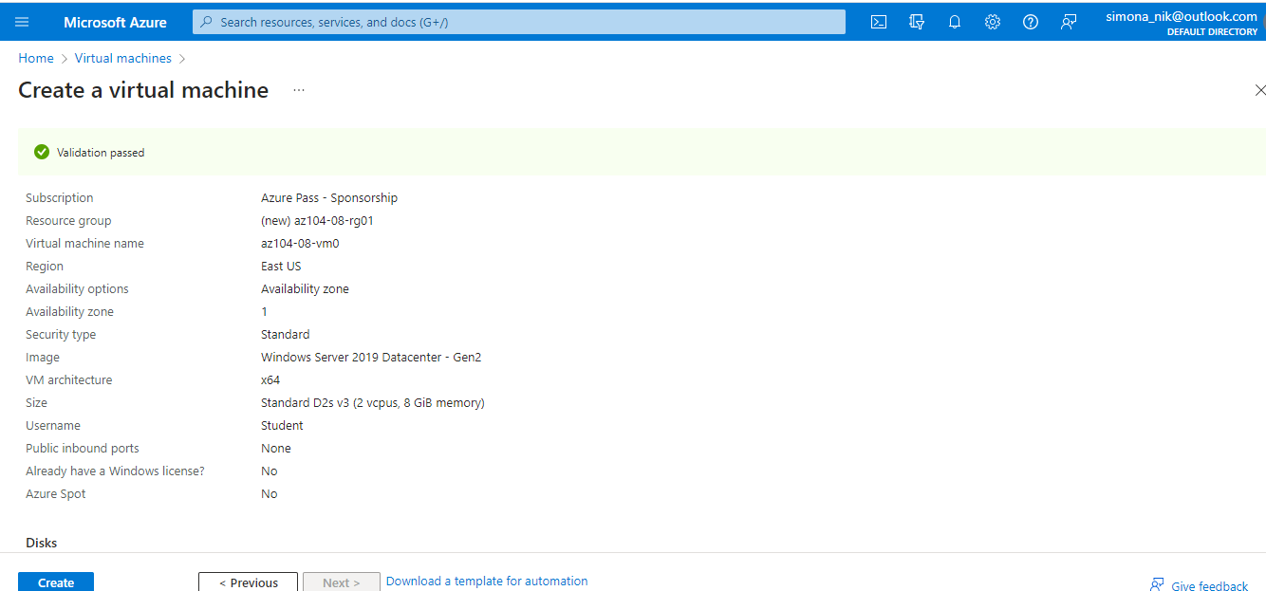

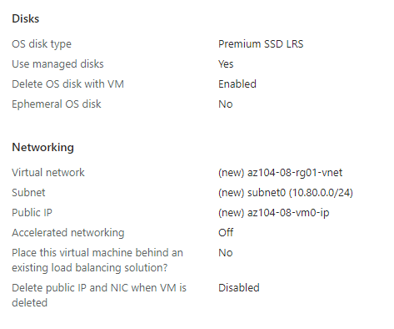

In this pictures are shown the required parameters for the virtual machine and then it is created. After the creation of the first VM, on the deployment blade we click **Template and then Deploy. We use** this option to deploy the second virtual machine with matching configuration except for the availability zone and if one zone is down it will continue on the other so we don’t lose informations.

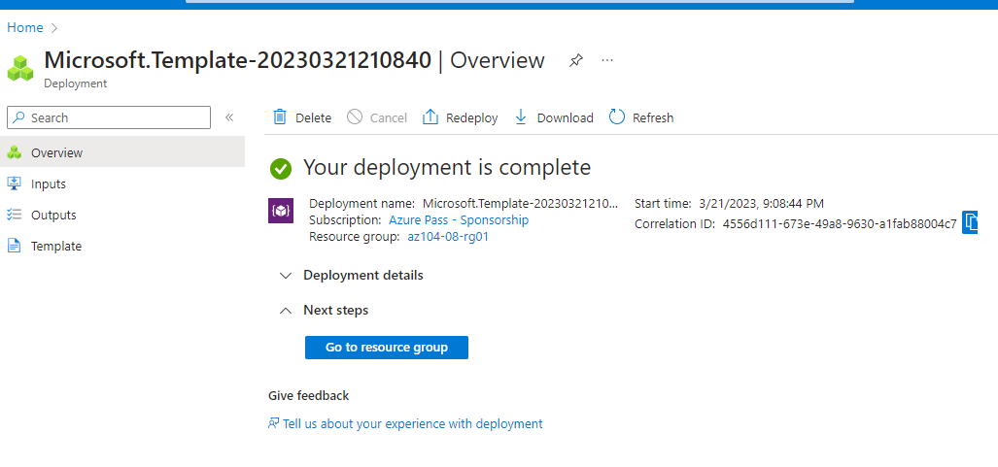

#### Task 2: Configure Azure virtual machines by using virtual machine extensions

First we create container named ‘scripts’ in the storage account created in the previous task

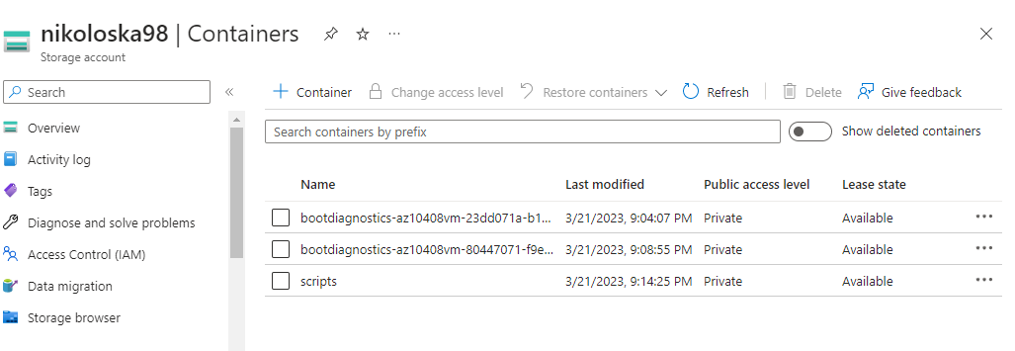

Then in the scripts is uploaded az104-08-install_IIS.ps1 file

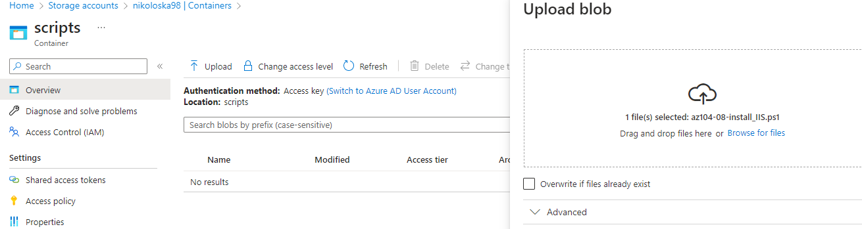

Next an extension is installed

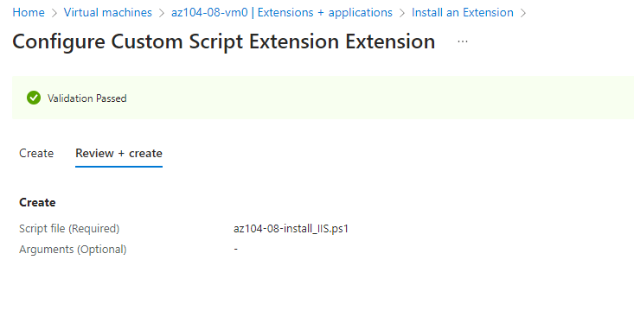

For the second virtual machine the template is exported and edited with entering code which defines the same Azure virtual machine custom script extension that I deployed earlier to the first virtual machine via Azure PowerShell

To verify that the Custom Script extension-based configuration was successful, I navigate back on the **az104-08-vm1** blade, in the **Operations** section and enter the command: Invoke-WebRequest -URI http://10.80.0.4 –UseBasicParsing and we get the following output:

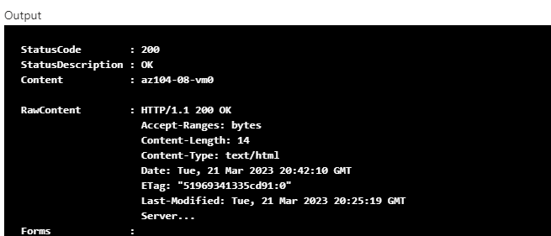

#### Task 3: Scale compute and storage for Azure virtual machines

In this task first we resize vm0 machine to DS1_v2:

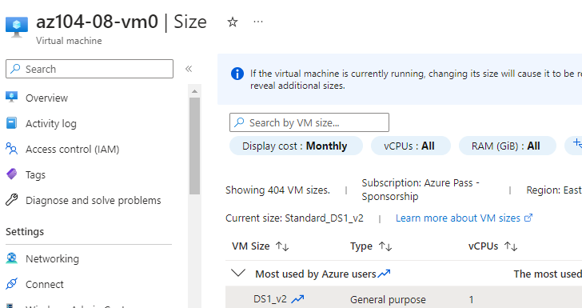

Next a disk is created:

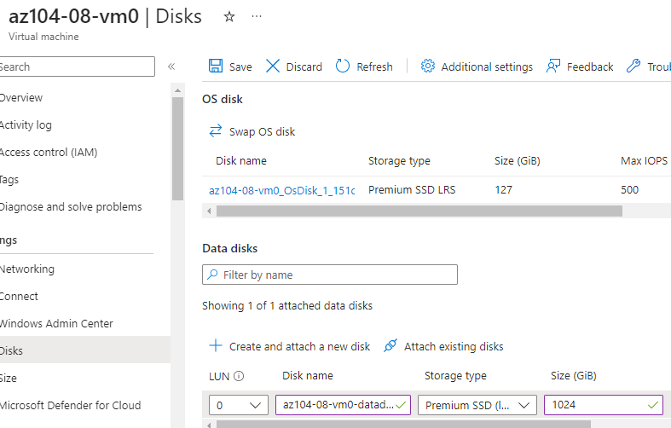

Then on the vm0 machine blade we choose to run a command that  creates a drive Z: consisting of the two newly attached disks with the simple layout and fixed provisioning

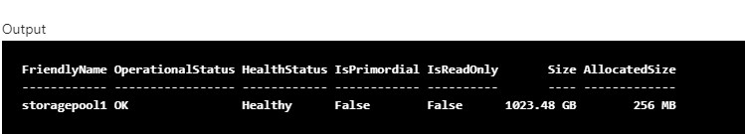

For the vm1 the template is again exported and edited on line 30: "vmSize": "Standard_DS1_v2" and also in line 51 is added code creates two managed disks and attaches them to **az104-08-vm1**

#### Task 4: Register the Microsoft.Insights and Microsoft.AlertsManagement resource providers

To register the Microsoft.Insights and Microsoft.AlertsManagement resource providers we need to use the following commands:

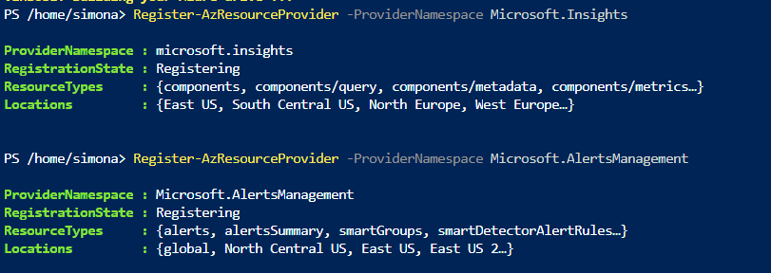

#### Task 5: Deploy zone-resilient Azure virtual machine scale sets by using the Azure portal

In this step a virtual machine scale set is created and also a new virtual network and network security group with added inbound rule

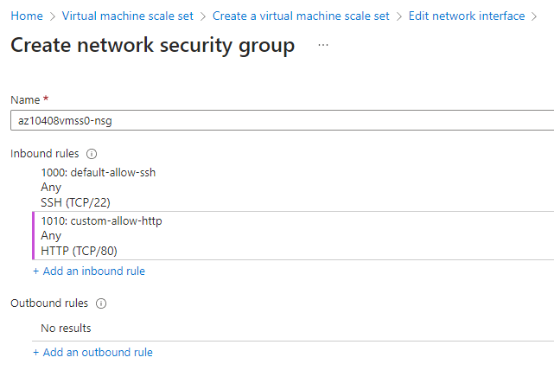

#### Task 6: Configure Azure virtual machine scale sets by using virtual machine extensions

In the diagnostics storage account from the previous task a new container is created and basically the steps are repeating because again the file is uploaded in the scripts. Then again is added extension

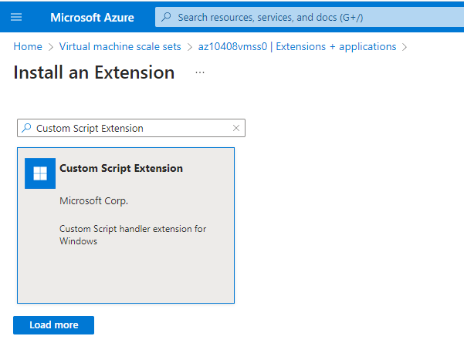

Instances are upgared:

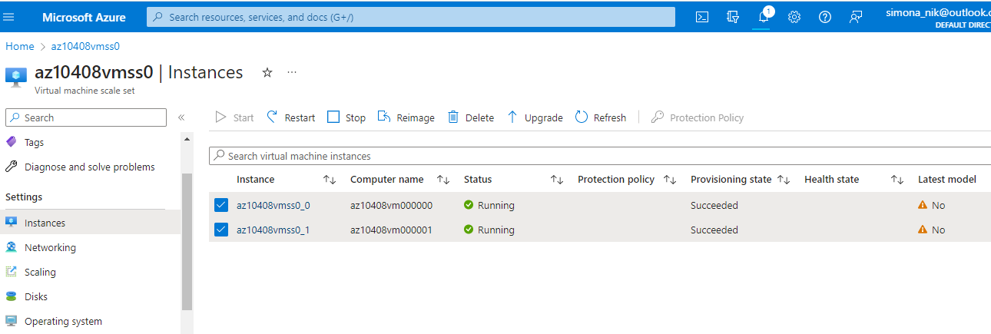

#### Task 7: Scale compute and storage for Azure virtual machine scale sets

Again the 2 instances are upgraded and for Scaling we choose Custom

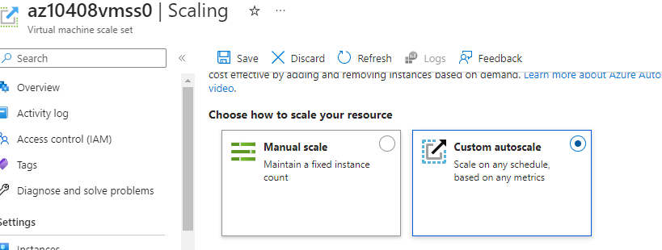and scale mode is Scale based on a metric. Then a rule is added:

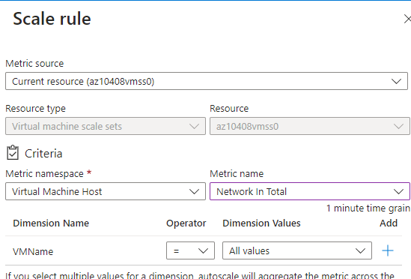

From the Cloud Shell pane, the following code is to identify the public IP address of the load balancer in front of the Azure virtual machine scale set **az10408vmss0 (for the IP is taken the one from the load balancer** *Public ip address: 20.108.178.29 (az10408vmss0-ip)*



 to start an infinite loop that sends the HTTP requests to the web sites hosted on the instances of Azure virtual machine scale set **az10408vmss0:**

while ($true) { Invoke-WebRequest -Uri "http://$pip" }

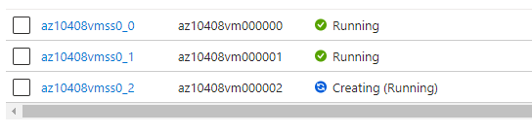

The third instance has different zone then the others two and we upgrade all three. Then the CustomScriptExtension is uninstalled and in PowerShell we upload **az104-08-configure_VMSS_disks.ps1**  file

to display the content of the script:

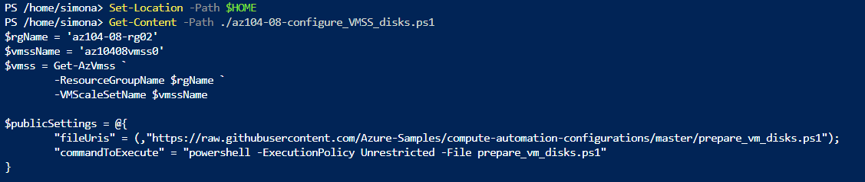

to excecute the script and configure disks of Azure virtual machine scale set:

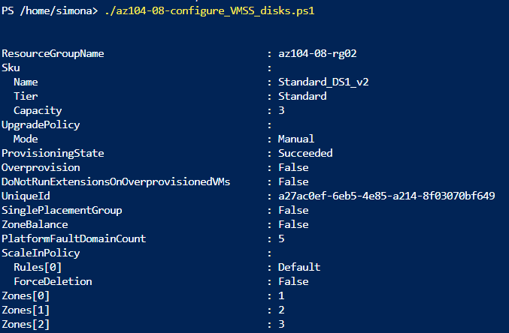

In the end all resources are deleted.